Product Design
Team 5 :
Vishnu Tej MP (Team Coordinator)
Ziyi Bai (Development Coordinator)
Priyank Kapadia (Development Coordinator)
Hector Valdecantos (Requirements Coordinator)
Antar Vasi (Test Coordinator)

Architectural Overview
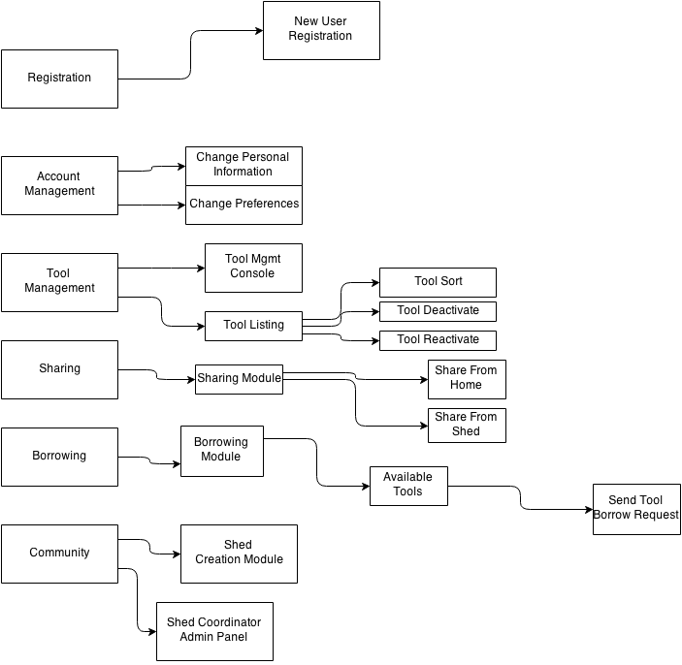

Components and Functions

Secure Registration | Component state:  - Secure storage of user's information  - User's id (email), encrypted user's passwords, date of creation, last login, login counter.  Component behavior:  - Secure usage storage of user's information, authentication and authorization.  - For authorization Roles: Coordinator, neighbor, site administrator.  - {neighbor (assigned on registration), shed coordinator (assigned on shed creation), site administrator (pre-assigned by the system)}  Functions:  - registration  - login  - password recovery  - authentication  - authorization  - roles assignment
Account Management | Component state:  - Storage of neighbor's information  - user's profile as name, last name, phone number, address.  Component behavior:  - Create, update personal information. Allows to cancel the account.  Functions:  - Account creation  - Change personal information  - Change community  - Cancel account
Sharing Management | Component state  - Maintain all the information about the sharing, like the arrangements, requests, rejections, pickups date, start and end dates.  Component behavior  - Set the information related to sharing, control the mechanism and restrictions of sharing, borrowing, requesting a tool.  Functions:  - Create share zone  - Sharing preferences  - Tool availability list  - Request a tool  - Approving  - Rejection  - Reservation  - Arrangement, sharing from: {home, community}  - borrowing  - returning  - sharing  - Owner/coordinator acknowledgement  - Manage tool state {Available (mark as present), returned, missing, }
Tool management | Component state  - Tools information: description, location  Component behavior  - Creation of tools, listing of availability tools, returning a tool.  Functions:  - Tool registration (Tool CRUD)  - Change tool information  - Activate tool (by owner)  - Deactivate tool (by owner)  - Show tool status {owner's tools}  - Set pickup location  - Set returning location  - Tool listing (different criteria)  - Shed creation
Statistic | Component state  - Acquire information from other components  Component behavior  - Statistic module might support all the process to obtain statistical information from the information of other modules. It shows statistics from distinct share zones:  Functions:  - most active lenders  - most active borrowers  - most used tools

Class Diagram(s)
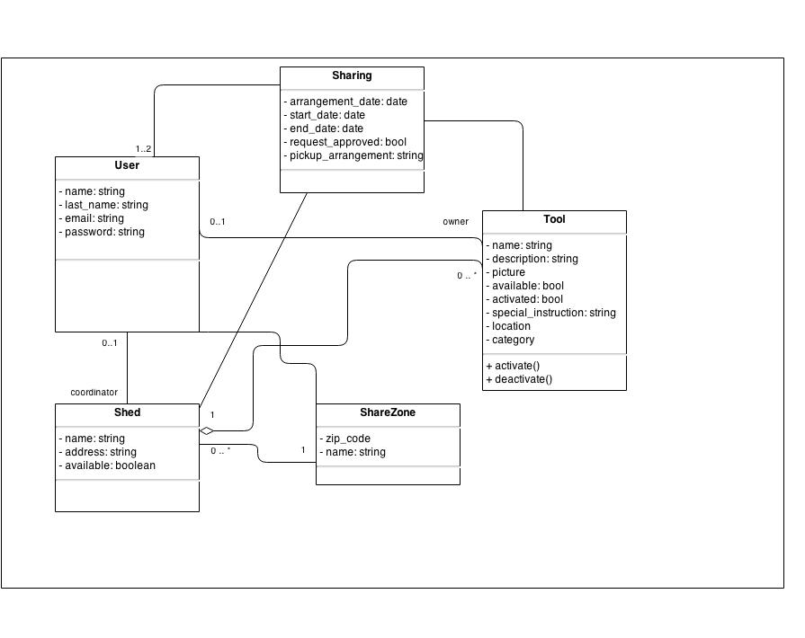

Sequence Diagram(s)
Sequence diagram for borrowing a tool and sharing. 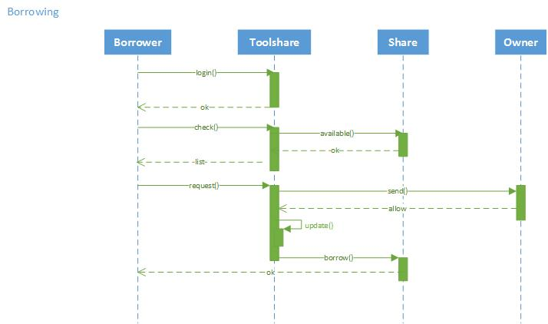

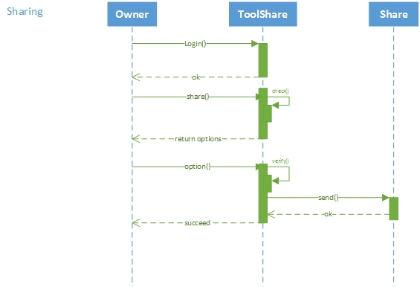

Design Rationale
Decided to branch feature wise on the repository instead of working on the single development repository as it would be most efficient. Branching features based of use cases defined in the requirements document verbatim. Understanding the requirements and specifications of an Architectural overview design. Design motive initially inflicted by database and code directives, but later edited design to make it look more UML based as those concerns could be later addressed in the project. Decided to combine security and Registration features as you would need security only to enter the system and not beyond that for simplicity.
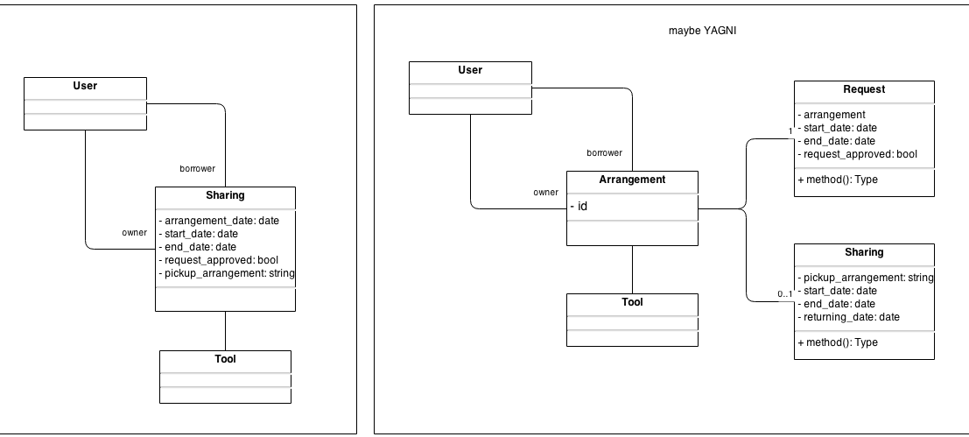
The diagram structure on the right was deemed to be excessive and hence we decided to use the design on the left so that it would be easier and more accurate to code and develop. Used one to one relationship table with existing django user authentication model instead of implementing from the base abstract model provided by django. This decision was taken by the team as a whole to use the django modules as much as we could for stability and easier to implement purposes. Agreed upon removing category and additional management features from the code as they were not required. Decided to use class based views initially but we were not able to gain enough expertise in this method and hence reverted to the standard model based or function based views to implement the initial features. Extended model forms for registration over creating custom model forms. Database needed to be cleared upon every instance for initialization purposes to synchronize the models as they were being changed and because of that the data inside the database was being removed every single time, to tackle this problem, we used the application named south to use migrations within the project to handle this better. This was a better alternative to using scripts in our view and we decided to go with this decision as it saves a lot of time. HTML’s were being written individually as the features were being developed, but we decided to revert to a base HTML which extends onto each and every HTML page to make the design more consistent. Django apps such as local flavor and south were used to reduce coding effort and save developer time as they are in built features which can be used in this application. Each and every time we had to load the tool categories to function with the application in the tool registration module, so to tackle this we have created a “.json” file to load the initial data so that the categories can be picked from a list.

